|  |
| --- |
| **All about me - Autumn 1** |
| **Communication and Language:**  Understand how to listen carefully and why listening is important.  Engage in story times. |
| **Personal, Social and Emotional Development:**  See themselves as a valuable individual. |
| **Physical Development:**  GM: Line up and move safely around the school.  GM: Use their core muscle strength to achieve a good posture when sitting at a table or sitting on the floor |
| **Literacy:**  Read individual letters by saying the sounds for them. |
| **Mathematics:**  Subitise. |
| **Understanding the World:**  Talk about members of their immediate family and community.  Name and describe people who are familiar to them. |
| **Expressive Art and Design:**  Sing in a group or on their own, increasingly matching the pitch and following the melody. |

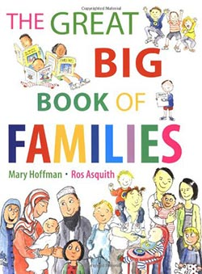

Children will start the term learning to move around the school safely. Physical development is incorporated in all areas of the setting. Children will develop their fine motor skills through adult directed activities.

Little Wandle phonics starts at the beginning of Autumn 1. Pupils with begin to learn letter sound correspondence and oral blending and segmenting in daily phonics and reading practise sessions.

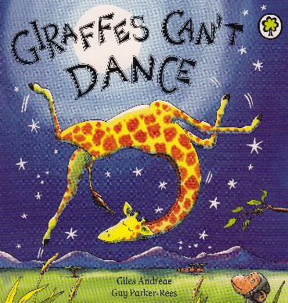

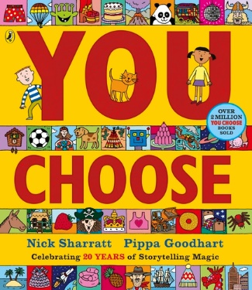

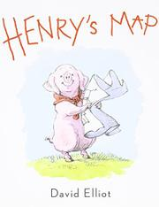

Following White Rose Maths, children will begin to subitise pictures and concrete objects to 5. This will take place during math group time and during curiosity time where children will be encouraged to apply their maths learning during their play.

This term children will be talking about members of their immediate family and who they live with. They will discuss how their family compares with others and learn about different houses around the world.

Singing is an important aspect of our curriculum. Children will begin by learning new songs focussing on actions and words. Throughout the year children’s imaginative storytelling will develop through telling Helicopter Stories.

|  |  |  |  |  |  |  |  |  |  |
| --- | --- | --- | --- | --- | --- | --- | --- | --- | --- |
|  | Communication & Language | Personal, Social and Emotional Development | Physical Development | Literacy | Mathematics | Understanding the World | Expressive Art and Design | Key Vocabulary | Key texts, poems and songs |
| **Week Beginning:**  16.09.2024 | **Objective:**  To look at an adult whilst listening to a story | **Objective:**  To know the name of their teachers | **Objective:**  GM: To walk in the corridors  FM: To explore different tools | **Objective:**  To listen to a story | **Objective:**  To subitise | **Objective:**  To name other members of their class | **Objective:**  To investigate the marks and patterns made by different textures | EAD  Pattern, texture, marks, colours, observe, material, portrait  Family, mum, dad, brother, sister, grandmother, grandfather, home, special, unique,  Maths  Subitise, match, sort, compare, more, fewer | PB: Chop chop |
| **Enhancement:**  Story time  Story reading during provision | **Enhancement:**  Repetitive name games (circle time) | **Enhancement:**  Group time – walking round the school | **Enhancement:**  Story time  Story reading during provision | **Enhancement:**  **Dice games** | **Enhancement:**  Group time – name games | **Enhancement:**  Kapow Lesson 1 | Say good morning  Days of the week |
| **Week Beginning:**  23.09.2024 | **Objective:**  To know how to do good listening | **Objective:**  To know the name of their class and respond when called | **Objective:**  GM: To work as a group to move large equipment  FM: To explore different tools | **Objective:**  To say a sound for an induvial letter | **Objective:**  To subitise | **Objective:**  To create a simple map using pictures | **Objective:**  To explore marks with felt tips | A great big book of families  PB: Pointy hat |
| **Enhancement:**  Circle time game –  Listening story – Freddy and the Fairy  Simon Says | **Enhancement:**  Repetition | **Enhancement:**  Move wooden blocks to make a pirate ship | **Enhancement:**  **I spy games**  **Different objects and pebble letters** | **Enhancement:**  **Dots on board – show on finger** | **Enhancement:**  **Classroom maps**   * Map paper | **Enhancement:**  Kapow Lesson 2 | With my family  (words below) |
| **Week Beginning:**  30.09.2024 | **Objective:**  To explain why listening is important | **Objective:**  To talk about their family members | **Objective:**  GM: To line up behind the person in front of them  FM: To develop threading skills | **Objective:**  To say a sound for an induvial letter | **Objective:**  To match, sort and compare objects | **Objective:**  To name and describe members of their family | **Objective:**  To explore making marks with chalk | You choose!  PB: 5 little pumpkins |
| **Enhancement:**  **Circle time** | **Enhancement:**  **UTW group time**  **Family portrait drawing**  **Email photos of family in to talk about** | **Enhancement:**  **Different threading activities**  **Line up games**   * Obstacle courses | **Enhancement:**  **Tactile letters**  **Big book and label pebbles on pictures** | **Enhancement:**  Sorting circles and animal/colours tiles | **Enhancement:**  **Use family portraits to talk about** | **Enhancement:**  Kapow Lesson 3 | Grandma’s glasses (see words below) |
| **Week Beginning:**  07.10.2024 | **Objective:**  To listen and sing as part of a group | **Objective:**  To play something they like with an adult | **Objective:**  GM: To walk in a line with space between the person in front of them  FM: To develop threading skills | **Objective:**  To blend three letters to read CVC words | **Objective:**  To match, sort and compare objects | **Objective:**  To talk about what they do with their family | **Objective:**  To explore mark making using pencils | Giraffes can’t dance  PB: Wise old owl |
| **Enhancement:**  **Singing group time** | **Enhancement:**  **CP** | **Enhancement:**  **Different threading activities**  Making bracelets – beads and ribbon | **Enhancement:**  **Cvc picture matching activity** | **Enhancement:**  Lady bird cards (in maths box in cupboard) | **Enhancement:**  Small world role play, home corner | **Enhancement:**  Kapow Lesson 4 | Around my home  (twinkl song below) |
| **Week Beginning:**  14.10.2024 | **Objective:**  To answer ‘what’ questions about a story | **Objective:**  To play something they like with an adult | **Objective:**  GM: To sit with good posture on the carpet  FM: To explore kneading and rolling dough | **Objective:**  To blend three letters to read CVC words | **Objective:**  To compare size, mass and capacity | **Objective:**  To create a simple map of their family home | **Objective:**  To create a simple observational drawing | A place called home  PB: Falling apples |
| **Enhancement:**  Story time, model what questions | **Enhancement:**  Board games, turn taking games | **Enhancement:**  Make playdough  Make bread dough | **Enhancement:**  **Phonics cubes** | **Enhancement:**  **Balance scales** | **Enhancement:**  Square paper  Example maps | **Enhancement:**  Kapow Lesson 5 | In our houses  (twinkl song below) |
| **Week Beginning:**  21.10.2024 | **Objective:**  To share if they like or dislike a story | **Objective:**  To share their likes and dislikes  To walk safely near roads | **Objective:**  GM: To walk safely near roads  FM: To explore kneading and rolling dough | **Objective:**  To blend three letters to read CVC words | **Objective:**  To explore, copy, continue and create simple patterns | **Objective:**  To compare their home with houses around the world | **Objective:**  To use a variety of colours and materials to create a self-portrait | Henry’s map  PB: A basket of Apples |
| **Enhancement:**  Story time | **Enhancement:**  Send in pictures of family activities to discuss | **Enhancement:**  **Walk to the library** | **Enhancement:**  **Chalk write cvc words on ground to read and jump on** | **Enhancement:**  Blocks, cubes, counting bears, example patterns to create and finish | **Enhancement:**  Draw pictures of their house  Compare houses around the world | **Enhancement:**  Kapow Lesson 6 | Lots of different places (twinkl song below) |

|  |  |
| --- | --- |
| Skills check | Ideas to build into term |
| 1. Become a curious learner |  |
| 1. Take care of themselves | Walk safely near roads |
| 1. Draw a map | Talk like a pirate day |
| 1. Follow a recipe to make a pizza | Kneading and making playdough |
| 1. Tell a story | Helicopter stories |
| 1. Saw a hand puppet | Threading |
| 1. Plan a celebration |  |
| 1. Create a self portrait | Family portraits |

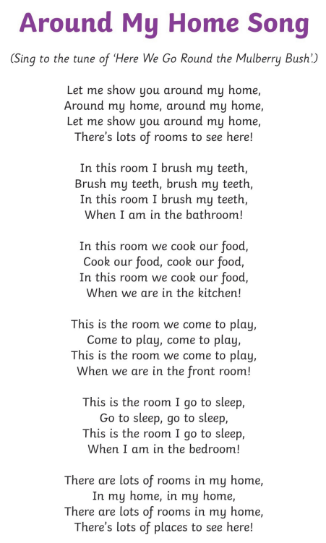

**With my family**

Tell me what you like to do  
Like to do, like to do.  
Tell me what you like to do  
With your family.  
(Sally*) likes to (go swimming**)  
Go swimming, go swimming.  
Sally likes to go swimming  
With her family.

**These are Grandma’s glasses**

These are Grandma’s glasses (Make glasses over eyes with fingers)  
This is Grandma’s hat (Place hands on top of head)  
And this is the way she folds her hands (Clasp hands together)  
And lays them in her lap (Place hands in lap).

 Recite second verse in a deep voice:

These are Grandpa’s glasses (Make bigger glasses shapes over eyes with fingers)  
This is Grandpa’s hat (Place hands over head to form a large hat)  
And this is the way he folds his arms (Cross arms)  
And takes a little nap (Place head on arms as if sleeping).