|  |
| --- |
| **Reception Autumn 2 What can I see through a telescope?** |
| **Communication and Language:**  Learn new vocabulary.  Learn rhymes, poems and songs. |
| **Personal, Social and Emotional Development:**  Build constructive and respectful relationships |
| **Physical Development:**  FM: Develop skills of measuring, kneading, mixing, rolling, stretching.  FM: Thread a needle. |
| **Literacy:**  Write their name. |
| **Mathematics:**  Continue, copy and create repeating patterns |
| **Understanding the World:**  Move Beebots on grid maps.  Comment on images of familiar situations in the past |
| **Expressive Art and Design:**  Perform puppet shows.    Explore colour mixing to make secondary colours.  Children will learn how to move a BeeBot and how to program a BeeBot to move a simple algorithm.  In the second half of the term children will look at how people celebrated Christmas in the past and discuss photos. |

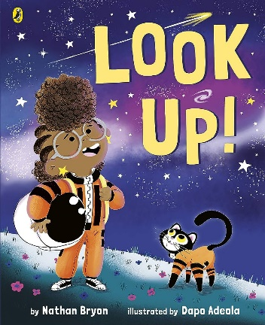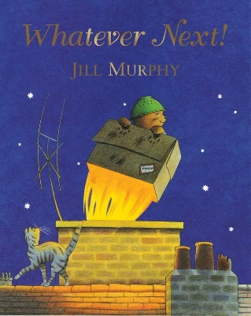

This term children will be tracing the letters of their name and practising letter formation.

We will be continuing Drawing Club this term. Children will be using their imagination and starting to write special ‘codes’.

As part of our ‘Sew a puppet’ skill children will have lots of practise with threading needle. To develop the fine motor skills needed to complete this task a range of fine motor activities will be available in the setting.

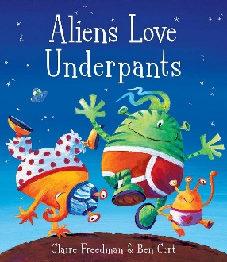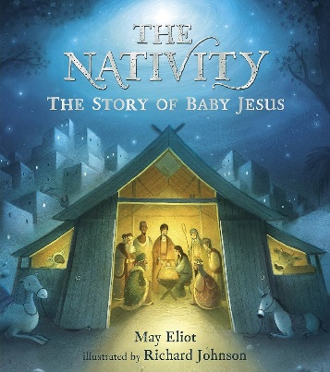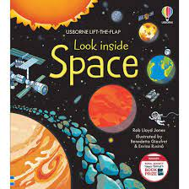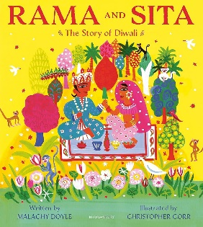

This term we will be making lots of different puppets to perform puppet shows. The children will perform well known stories and be encouraged to create their own. In the studio, children will learn how to mix colours to make secondary colours using a range of different media including paint, oils, cellophane and tissue paper.

Children will use a variety of objects and natural items to make ABAB and ABBABB patterns. Stories with noticeable patterns will be shared and children will talk about and describe patterns in their environment.

|  |  |  |  |  |  |  |  |  |  |
| --- | --- | --- | --- | --- | --- | --- | --- | --- | --- |
|  | Communication & Language | Personal, Social and Emotional Development | Physical Development | Literacy | Mathematics | Understanding the World | Expressive Art and Design | Key Vocabulary | Key texts and songs |
| **Week Beginning:**  **Tues 5.11.24**  **5.11 – Guy Fawkes Night**  **(Diwali 31.10 – 1.11)** | **Objective:**  To use new space vocabulary | **Objective:**  To discuss how to be a good friend | **Objective:**  FM: Thread a needle  GM: To develop balance and jumping | **Objective:** To put the letters in their name in the right order | **Objective:**  To copy and create repeating patterns | **Objective:**  To describe how Diwali is celebrated | **Objective:**  To create Diwali decorations | Space  Star  Rocket  Tool  Planet  Space  Telescope  Astronomy  Astronaut  Asteroid  Asteroid belt  Orbit  Meteor  Planet names – (Mercury, Venus, Earth, Mars, Jupiter, Saturn, Uranus, Neptune)  Diwali  Fireworks  Lantern  Diya lamp  Rama  Mehndi  Jewellery  Gifts  Cards  Festival  Celebration | Whatever Next! – Jill Murray  Look Up! |
| **Enhancement:**  Have vocabulary words with visuals  Space books | **Enhancement:**  Turn taking games | **Enhancement:**  Assault courses with large wooden blocks (inside) | **Enhancement:**  Pebble letters  Laminated name writing | **Enhancement:**  Natural objects  Threading  Cubes | **Enhancement:**  Decorate home corner for Diwali  Rama and Sita masks | **Enhancement:**  Rangoli rice patterns in tuff trays  Rama and Sita story props | PB: Leaves are falling  DC: Not Now Bernard  Planet song (hopscotch) <https://www.youtube.com/watch?v=PCxjuDePdCI> |
| **Week Beginning:**  **11.11.24**  **11.11 – Remembrance** | **Objective:**  To use new space vocabulary | **Objective:**  To ask a friend to play | **Objective:**  FM: Thread a needle  GM: To develop balance and jumping | **Objective:**  To form the letters of their name correctly | **Objective:**  To find, subitise and represent 1,2 and 3 | **Objective:**  To create a space map  To name the planets in the solar system | **Objective:**  To create group artwork based on fireworks | Aliens Love Underpants |
| **Enhancement:**  Have vocabulary words with visuals  Space books  Space role play with rocket | **Enhancement:**  Lots of modelling  Turn taking games  Snakes and ladders | **Enhancement:**  Use large blocks to build a rocket | **Enhancement:**  Laminated name writing | **Enhancement:**  Matching activities  Dice rolling | **Enhancement:**  Black paper and silver pens  Paper mache planets | **Enhancement:**  **Kapow – Paint my world lesson 6**  **Group artwork** | PB: Breezy Weather  DC: Not Now Bernard |
| **Week Beginning:**  **18.11.24** | **Objective:**  To use new space vocabulary | **Objective:**  To understand how to take turns (not share/give up) | **Objective:**  FM: Thread a needle GM: To walk near roads safely | **Objective:**  To form the letters of their name correctly | **Objective:**  To find one more and one less  To compose numbers to 3 | **Objective:**  To understand what space is  To name our planet as Earth | **Objective:**  To explore colour mixing  To self-serve paint | The Story of Rama and Sita  Mr Men Diwali story |
| **Enhancement:**  Have vocabulary words with visuals  Space books  Space role play with rocket | **Enhancement:**  Lots of modelling  Turn taking games  Lego building sets | **Enhancement:**  Walk to Tesco to buy ingredients for bread/ discuss road safety | **Enhancement:**  Laminated name writing | **Enhancement:**  Sharing in role play (can I have one more?) | **Enhancement:**  Singing planet song | **Enhancement:**  Rub hands in paint with hand prints | PB: Who has seen the wind?  DC: Little Red Hen |
| **Week Beginning:**  **25.11.24**  **Rehearsing** | **Objective:**  To use new space vocabulary  Have vocabulary words with visuals  Space books  Space role play with rocket | **Objective:**  To be a good talk partner | **Objective:**  FM: Develop skills of measuring, kneading, mixing, rolling, stretching  GM: To pass a ball in different ways | **Objective:**  To write the letters of their name in the right order | **Objective:**  To find, subitise and represent 1,2, 3, 4 5 | **Objective:**  To describe what a telescope can do  To move a BeeBot on a simple grid map | **Objective:**  To learn a new song | Look Inside Space |
| **Enhancement:**  Acting out space stories, dressing up, singing space songs | **Enhancement:**  Group times | **Enhancement:**  Make bread dough | **Enhancement:**  Laminated name writing practice | **Enhancement:**  Dice rolling games | **Enhancement:**  Bee bot space mat | **Enhancement:**  Christmas Nativity songs | Nativity songs  PB: Cup of Tea  DC: Little Red Hen |
| **Week Beginning:**  **2.12.24**  **Rehearsing** | **Objective:**  To learn the words to new songs | **Objective:**  To listen to a talk partner and remember what was said | **Objective:**  FM: Develop skills of measuring, kneading, mixing, rolling, stretching  GM: To pass a ball in different ways | **Objective:**  To write an invitation | **Objective:**  To find, subitise and represent 4 and 5 | **Objective:**  To describe how Christmas was celebrated in the past | **Objective:**  To sing as part of a group  To perform puppet shows | Christmas  Party  Christmas  Celebrate  Stocking  Decoration  Past  Present  Tinsel  Bauble  Garland  Nativity  Mary  Joseph  Donkey  Angel  Wise man  Shepherd  Census | The Nativity |
| **Enhancement:**  Nativity songs | **Enhancement:**  Group times – tell me what your partner said… | **Enhancement:**  Playdough  Different sized balls outside, Piggy in the Middle, balls passing games | **Enhancement:**  Nativity invitation writing | **Enhancement:**  Setting up the home corner for dinner for 3, 4 and 5 | **Enhancement:**  Pictures showing Christmas in the past, stories (Shirley Hughes) | **Enhancement:**  Rehearsing Nativity songs, loud singing with actions  Puppets and puppet theatre, making tickets | Nativity songs  PB: Mice |
| **Week Beginning:**  **9.12.24**  **Christmas Performances**  **13.12.24**  **Christmas Jumper Day** | **Objective:**  To learn the words to new songs | **Objective:**  To say something nice about someone else | **Objective:**  FM: Develop skills of measuring, kneading, mixing, rolling, stretching  GM: To pass a ball in different ways | **Objective:**  To write a list | **Objective:**  To find one more and one less  To compose numbers to 5 | **Objective:**  To compare how Christmas was celebrated in the past to now | **Objective:**  To perform a play  To perform puppet shows | Christmas stories TBC |
| **Enhancement:**  Additional Christmas songs, making music with bells | **Enhancement:**  Compliment someone else’s performance | **Enhancement:**  Playdough  Different sized balls outside, Piggy in the Middle, balls passing games with additional instructions eg pass behind your back, pass between your knees | **Enhancement:**  List writing templates, party food lists, Christmas shopping lists | **Enhancement:**  Roll the dice, tell me 1 more/1 less, draw 1 more/1 less than the number shown | **Enhancement:**  Photos from Christmas in the past (ask grandparents/older relatives to send in) | **Enhancement:**  Nativity performance | Nativity songs  PB: Shoes |
| **Week Beginning:**  **16.12.24**  **Panto 18.12.24**  **Party Day 19.12.24** | **Objective:**  To learn the words to new songs | **Objective:**  To show care for a friend | **Objective:**  FM: Develop skills of measuring, kneading, mixing, rolling, stretching  GM: To pass a ball in different ways | **Objective:**  To write a letter  To write a card | **Objective:**  **Assessment week** | **Objective:**  To compare how Christmas was celebrated in the past to now | **Objective:**  To move and respond to music  To perform puppet shows | Christmas stories TBC |
| **Enhancement:**  Party songs and games | **Enhancement:**  Making a Christmas card for a friend | **Enhancement:**  Making and decorating Christmas biscuits | **Enhancement:**  Christmas/holiday season greetings cards | **Enhancement:**  Colour by number pictures | **Enhancement:**  Looking at old photos from family and friends | **Enhancement:**  Music express | PB: recap all poems |

|  |  |
| --- | --- |
| Skills check | Ideas to build into term |
| 1. Become a curious learner |  |
| 1. Take care of themselves |  |
| 1. Draw a map | Space maps |
| 1. Follow a recipe to make a pizza | Make bread dough |
| 1. Tell a story |  |
| 1. Saw a hand puppet | Thread a needle |
| 1. Plan a celebration | Write invitations  Decorations for Diwali  Decorate for Christmas |
| 1. Create a self portrait |  |