|  |
| --- |
| **Reception Spring 1 Who lives in the Arctic?** |
| **Communication and Language:**  Use new vocabulary through the day  Engage in non-fiction books. |
| **Personal, Social and Emotional Development:**  Know and talk about toothbrushing |
| **Physical Development:**  FM: form letters correctly, starting and finishing in the right place.  FM: To zip up a coat  GM: Develop core strength to assist when riding balance and two wheeled bikes. |
| **Literacy:**  Form lower-case and capital letters correctly |
| **Mathematics:**  Select, rotate and manipulate shapes to develop spatial reasoning skills. |
| **Understanding the World:**  Recognise some similarities and differences between life in this country and life in other countries.  Recognise some environments that are different to the one in which they live. |
| **Expressive Art and Design:**  Create party decorations. |

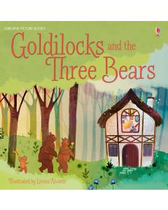

Throughout this term we will be introducing new vocabulary for our polar topic. Adults will model using the new vocabulary in all areas of the setting. In our drawing club sessions children will be introduced to eight new, ambitious words a week.

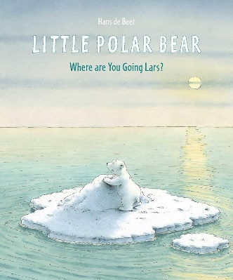

Shapes are always accessible in our provision. During play, children will be able to explore, select and rotate shapes to create new shapes.

A focus on letter formation this term will take place during our daily phonics sessions, daily name writing practice and with letter formation activities in our provision. Staff use letter formation ‘rhymes’ to help the children to start their letters in the correct place.

Using our Kapow lessons, children will explore junk modelling, cutting different materials and joining different materials.

We will use these skills to create party decorations for our Chinese New Year celebrations at the end of the half term.

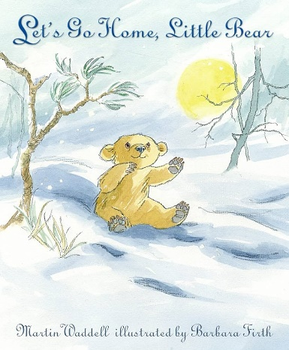

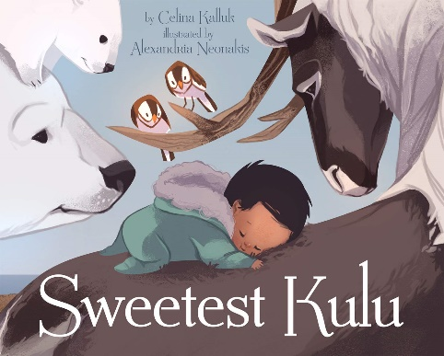

|  |  |  |  |  |  |  |  |  |  |
| --- | --- | --- | --- | --- | --- | --- | --- | --- | --- |
|  | Communication & Language | Personal, Social and Emotional Development | Physical Development | Literacy | Mathematics | Understanding the World | Expressive Art and Design | Key Vocabulary | Key texts and songs |
| **Week Beginning:**  **06.01.2025** | **Objective:**  To use new Arctic vocabulary | **Objective:**  To discuss the importance of toothbrushing | **Objective:**  GM: To move in different ways (crawl, roll, skip, hop) | **Objective:**  To form curly caterpillar letters | **Objective:**  Composition of 4 and 5  Composition of 1-5  Shapes with 4 sides | **Objective:**  To find where bears live on a map | **Objective:**  To explore the tools in the junk modelling area | UTW  frozen  disguise  forest  equator  frosty  iceberg  North Pole  Arctic  Environment  Forest  Brown bear  Moon bear  Giant Panda Sloth bear  Spectacled bear  Polar bear  Sun bear  Black bear | Goldilocks and the three bears (First 2 days back)  Something about a bear – Jackie Morris |
| **Enhancements**:  Arctic small world  Pre teach vocab | **Enhancements**:  Tuff tray in studio Big teeth, shaving foam | **Enhancements**:  Assault course outside | **Enhancements**: Letter tracing on light table on paper | **Enhancements**: | **Enhancements**:  Maps, bears, blank world maps | **Enhancements**:  Kapow Lesson 1 | Teddy Bears picnic  PB: Popcorn  DC: The Billy Goats Gruff |
| **Week Beginning:**  **13.01.2025** | **Objective:**  To use new Arctic vocabulary in well formed sentences | **Objective:**  To describe how to brush their teeth | **Objective:**  GM: To move in different ways (crawl, roll, skip, hop) | **Objective:**  To form curly caterpillar letters | **Objective:** | **Objective:**  To locate the Arctic on a map  To describe the environment bears live in | **Objective:**  To investigate cutting different materials | Little Polar Bear |
| **Enhancements**:  Matching bear names with pictures | **Enhancements**:  White playdough, mirrors, toothpaste | **Enhancements**:  Simon says, PE mats | **Enhancements**:  Roll and write letters | **Enhancements**: | **Enhancements**:  Images of where bears live  Matching pictures of bears with environments | **Enhancements**:  Kapow Lesson 2 | PB: A little house  DC: Room on the Broom |
| **Week**  **Beginning:**  **20.01.2025** | **Objective:**  To use new Arctic vocabulary  To ask questions to find out more information | **Objective:**  To ask for help if something is difficult | **Objective:**  GM: Develop core strength to assist when riding balance and two wheeled bikes. | **Objective:**  To form ladder letters | **Objective:** | **Objective:**  To recognise differences between how Inuit’s live and the UK | **Objective:**  To learn how to plan and select resources to make a model | Lets go home, little bear – Martin Waddell |
| **Enhancements**:  Question hands  Post it notes (write their questions near the bears) | **Enhancements**:  Talk about who helps us  Build a bear a house challenge – ask a friend to help | **Enhancements**:  Bikes out in the morning | **Enhancements**:  Letter tracing on light table on paper | **Enhancements**: | **Enhancements**:  Books, images, question hand | **Enhancements**:  Kapow Lesson 3 | PB: Pancakes  DC: Mr Benn - Zookeeper |
| **Week Beginning:**  **27.01.2025** | **Objective:**  To use non-fiction books to learn something new | **Objective:**  To try again when something is difficult | **Objective:**  GM: Develop core strength to assist when riding balance and two wheeled bikes. | **Objective:**  To form ladder letters | **Objective:** | **Objective:**  To recognise differences between how Inuit’s live and the UK | **Objective:**  To verbally plan and create a junk model | Little Polar Bear by Hans de Beer |
| **Enhancements**:  Visit the library | **Enhancements**:  Talking about perseverance | **Enhancements**:  Bikes out in the morning | **Enhancements**:  Roll and write letters | **Enhancements**: | **Enhancements**:  Make a model of an igloo | **Enhancements**:  Kapow Lesson 4 | PB: Mittens  DC: The Hairy Toe |
| **Week Beginning:**  **03.02.2025**  **Lunar New Year?** | **Objective:**  To use non-fiction books to learn something new | **Objective:**  To try again when something is difficult | **Objective:**  GM: Develop core strength to assist when riding balance and two wheeled bikes. | **Objective:**  To form capital letters for caterpillar and ladder letters | **Objective:** | **Objective:**  To compare how New Year is celebrated in Asia | **Objective:**  To explore ways to temporarily join materials together | Sweetest Kuku by Celina Kalluk |
| **Enhancements**:  Visit the library | **Enhancements**:  Talking about perseverance  Teacher role play | **Enhancements**:  Bikes out in the morning  Make own tracks | **Enhancements**:  Letter tracing on light table on paper | **Enhancements**: | **Enhancements**:  Lunar New Year real items  Chinese symbol  Lanterns, food tasting, dragon dances | **Enhancements**:  Kapow Lesson 5&6 | PB: I can build a snowman  DC: Jack and the Beanstalk |
| **Week beginning:**  **10.02.25** | **Objective:** | **Objective:** | **Objective:** | **Objective:** | **Objective:** | **Objective:** | **Objective:** |  |  |
|  | **Enhancements**: | **Enhancements**: | **Enhancements**: | **Enhancements**: | **Enhancements**: | **Enhancements**: | **Enhancements**: |  |  |

Emails:

Tooth brushes (Week 3)

Chinese food (week 4) *remember allergy children*

Parents to talk about Chinese new year?

|  |  |
| --- | --- |
| Skills check | Ideas to build into term |
| 1. Become a curious learner |  |
| 1. Take care of themselves | Dental visit |
| 1. Draw a map |  |
| 1. Follow a recipe to make a pizza |  |
| 1. Tell a story |  |
| 1. Saw a hand puppet |  |
| 1. Plan a celebration |  |
| 1. Create a self portrait |  |