|  |
| --- |
| **Reception Summer 1**  **Where is our School?** |
| **Communication and Language:**  Use new vocabulary in different contexts  Connect one idea or action to another using a range of conjunction. |
| **Personal, Social and Emotional Development:**  Think about the perspectives of others  Know and talk about being a safe pedestrian. |
| **Physical Development:**  FM: Develop different stitches  GM: refine moving in different ways. |
| **Literacy:**  Narrate a story for others to perform.  Re-read books to build confidence. |
| **Mathematics:**  Automatically recall number bonds for numbers 0-5 and some to 10. |
| **Understanding the World:**  Draw information from a simple map.  To use grid references |
| **Expressive Art and Design:**  Watch and talk about dance and performance art, expressing their feelings and responses. |

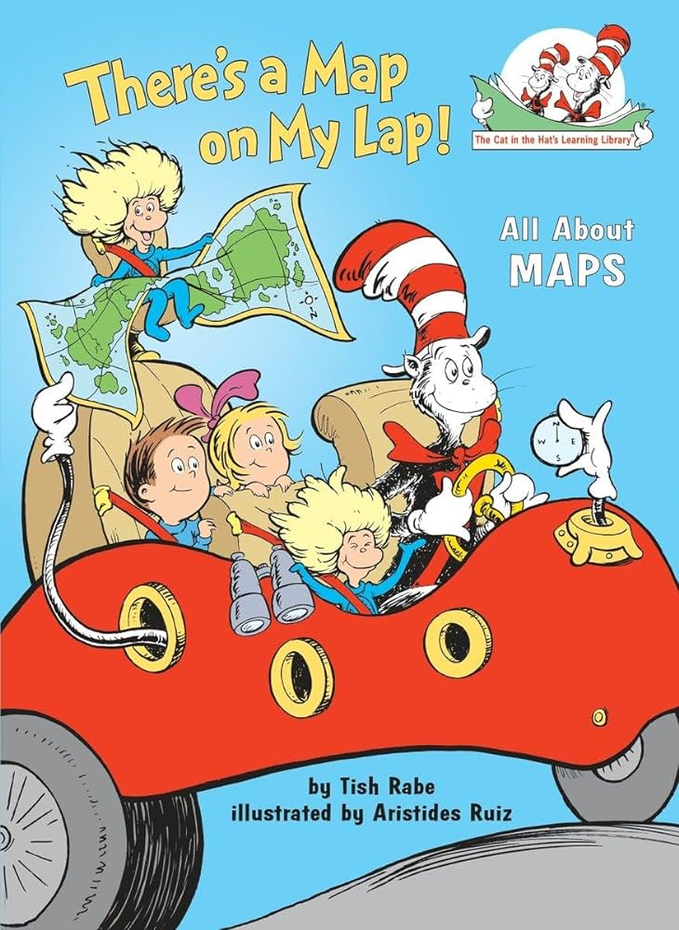

Using the outside area to model, children will be able to know and talk about how to be a safe pedestrian. They will role play walking along roads and how to cross roads safely before going on local walks and putting this into practice.

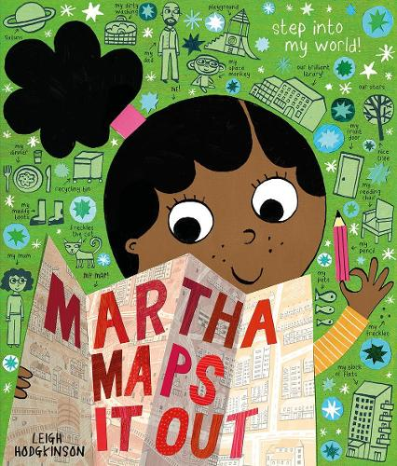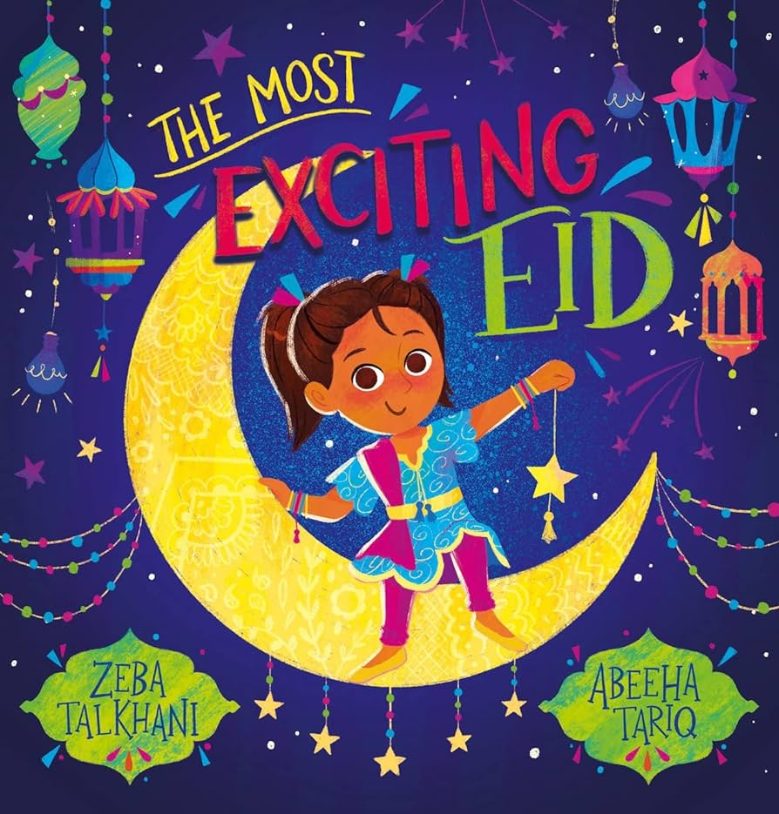

As children have become more confident with joining two pieces of fabric and using a needle and thread they will begin to explore ways to decorate fabric using stitches.

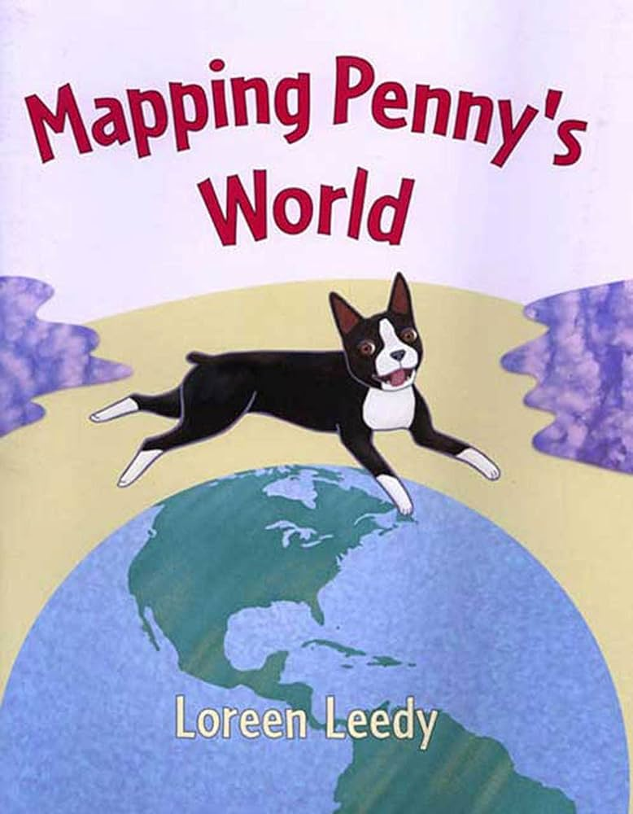

Children will be exposed to lots of different maps this term. They will create different types of maps and start to add more detail. They will begin to use grid references to describe location and play games.

Children will apply their previous learning to now quickly recall bonds within 5 and some within 10. This will be done through games, different representations and oral recall/stem sentences.

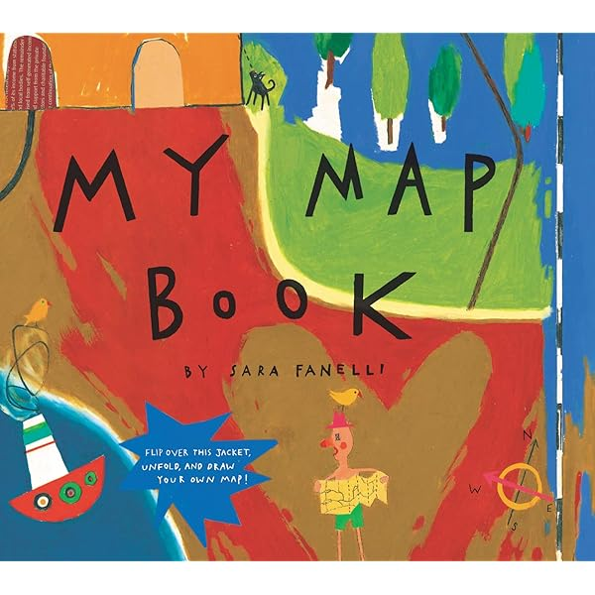

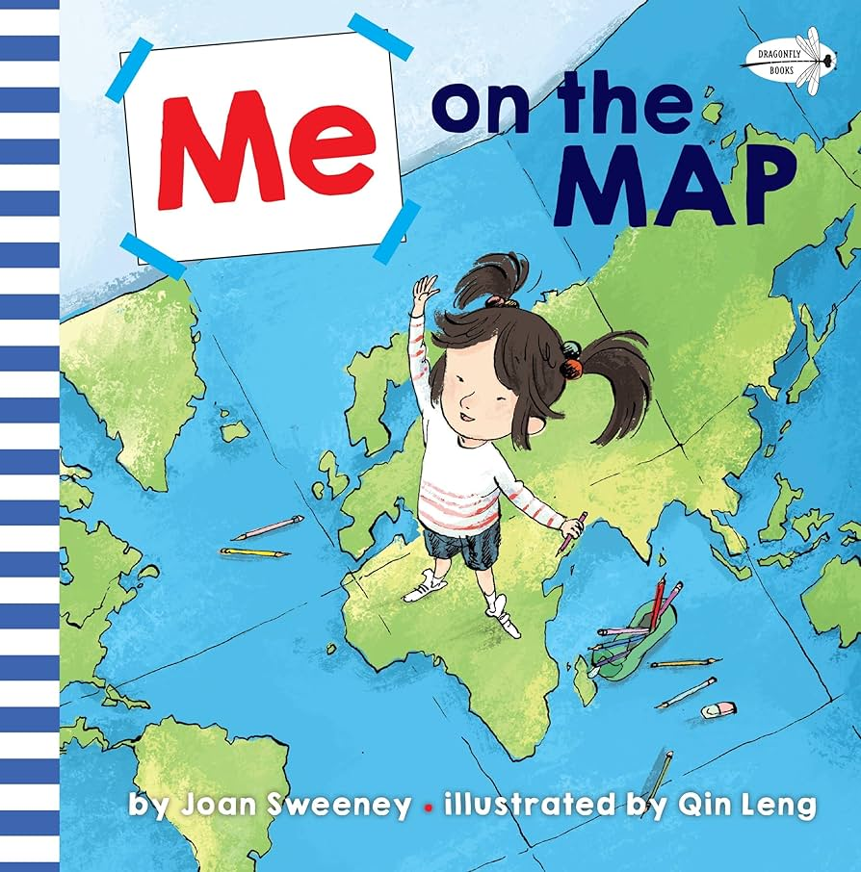

There will be lots of opportunities this term for children to express themselves through dance. They will be able to watch different types of dance and talk about what they like, if it interests them and how it makes them feel.

|  |  |  |  |  |  |  |  |  |  |
| --- | --- | --- | --- | --- | --- | --- | --- | --- | --- |
|  | Communication & Language | Personal, Social and Emotional Development | Physical Development | Literacy | Mathematics | Understanding the World | Expressive Art and Design | Key Vocabulary | Key texts and songs |
| **Week Beginning:**    21.04.2025  Chicks arriving! | **Objective:**  To use the conjunction because when speaking | **Objective:**  To explain how to be a safe pedestrian | **Objective:**  FM: to begin to use cross stitch for decoration  GM: Game on - TBC | **Objective:**  To retell a familiar story | **Objective:**  Building 9 and 10 | **Objective:**  To explain what a map is used for  **Objective:**  To observe the eggs and chicks hatching | **Objective:**  To explore clay and its properties | Eid  Religion  Calendar  Mosque  Prayers  Celebration  Muslim  Fasting  Festival  Ramadan  Chick  Grow  Egg  Incubator  Hatching  Pellets  Life cycle  map  place  all around  picture  above  location  environment  Cross stitch  Over  Under  Thread  Needle  Stitch  Sew  Decorate  Diagonal | The Lifecycle of chicks |
| **Enhancements**:  Silly sentence games | **Enhancements**:  Pictures of people crossing/walking along the road and hazards to discuss. | **Enhancements**:  Cross stitching on Binka | **Enhancements**:  Retell my favourite drawing club story. | **Enhancements**:  Sorting representations of 9 and not 9. | **Enhancements**:  Maps of Chesham. What do you recognise? Can you name features of the local area you find on the map?  Chicks – what can you see? What are they doing? What will they look like when they hatch? | **Enhancements**:  Kapow Lesson 1 | Me on the map: <https://www.youtube.com/watch?v=v_gUK8U9dE0> |
| **Week Beginning:**  28.04.2025 | **Objective:**  To use the conjunction but when speaking | **Objective:**  To know different types of road crossings | **Objective:**  FM: to begin to use cross stitch for decoration  GM: Game on - TBC | **Objective:**  To retell and act out a familiar story | **Objective:**  Building 9 and 10 | **Objective:**  To create a map of a journey around the school | **Objective:**  To explore playdough and its properties | Chick  Grow  Egg  Incubator  Hatching  Pellets  Life cycle  map  place  all around  picture  above  location  environment  journey  Cross stitch  Over  Under  Thread  Needle  Stitch  Sew  Decorate  Diagonal | <https://www.youtube.com/watch?v=pFnUzY9rugk>  My Map book  DC: |
| **Enhancements**:  Silly sentence games | **Enhancements**:  Pictures of types of road crossings  Outside area – belusha beacons, zebra crossing etc on track | **Enhancements**:  Cross stitching on fabric to decorate | **Enhancements**:  Role play clothes and props | **Enhancements**:  Double sided counters and 10 frames, 10 pirates on 2 islands outside. | **Enhancements**:  Maps, squared paper, photos of places around school to stick on maps | **Enhancements**:  Kapow Lesson 2 | Song: United Kingdom song  <https://www.youtube.com/watch?v=v6olllwsJPE> |
| **Week Beginning:**  05.04.2025 | **Objective:**  To use new vocabulary during their play | **Objective:**  To give instructions on how to walk safely | **Objective:**  FM: to begin to use cross stitch for decoration  GM: Game on - TBC | **Objective:**  To use intonation when telling a story | **Objective:**  Exploring 3D shapes | **Objective:**  To name the countries of the UK | **Objective:**  To create natural 3D landscape pictures | England  Scotland  Wales  Northern Ireland | <https://www.youtube.com/watch?v=3fIeLZprZcM> Martha maps it out  DC: |
| **Enhancements**:  Support target children with using new vocab – chatterlog | **Enhancements**:  Strips to write instructions, pictures to generate ideas | **Enhancements**:  Cross stitching on fabric to decorate | **Enhancements**:  Model intonation – link to prosody in reading practice | **Enhancements**:  Building with 3d shapes, 3d shape printing | **Enhancements**:  United Kingdom song on board – create actions  UK maps to look at, Atlas and maps to look at | **Enhancements**:  Kapow Lesson 3 | Song: United Kingdom song  <https://www.youtube.com/watch?v=v6olllwsJPE> |
| **Week Beginning:**  12.05.2025 | **Objective:**  To use new vocabulary during their play | **Objective:**  ~~To walk safely around the local area~~  Postponed to week 6 | **Objective:**  FM: to begin to use back stitch for decoration  GM: Game on - TBC | **Objective:**  To use intonation when telling a story | **Objective:**  Exploring patterns | **Objective:**  To design symbols for a map  To use grid references | **Objective:**  To generate inspiration and conversation about sculpture art and artists | Symbols  Picture  Represent  Grid  Map  Measure | <https://www.youtube.com/watch?v=wsYdpOANqhw>  Mapping Penny’s world  DC: |
| **Enhancements**:  Support target children with using new vocab – chatterlog | **Enhancements**:  Modelling how to explain to others how we feel  Talk about how to manage when our friends don’t want to play | **Enhancements**:    Sewing – continue | **Enhancements**:    Stage in book area  Masks  Reading practice | **Enhancements**:     Shape patterns  Number patterns | **Enhancements**:    Beebot map – UK with Grid references    UK flag colouring | **Enhancements**:  Kapow Lesson 4      UK Map collages | Continent song recap from Spring 1 |
| **Week Beginning:**  19.05.2025 | **Objective:**  To connect two ideas when speaking using conjunctions | **Objective:**  To describe how others feel in different scenarios | **Objective:**  FM: to begin to use back stitch for decoration  GM: Game on - TBC | **Objective:**  To reread books and answer questions | **Objective:** To 20 and beyond | **Objective:**  To locate the school on an ariel map/photograph  To use grid references | **Objective:**  To begin making a 3D clay sculpture | position  surroundings  photograph  overhead  satellite image  aerial  human feature  physical/natural feature | There’s a map on my Lap (Cat in the Hat) <https://www.youtube.com/watch?v=C1w5l-u3WA4>  DC: |
| **Enhancements**:  Silly sentence game. E.g I was going to play outside BUT it started to rain hotdogs.  Give children dojos for using the ‘but’ conjunction. | **Enhancements**:  Use stories at the end of the day to discuss difference characters’ feelings. | **Enhancements**:  Continue sewing on Binca fabric | **Enhancements**:  Read familiar stories/texts to children and ask questions | **Enhancements**:  Number line to 25 in the playground  Counting games | **Enhancements**:  Ariel maps/photos out for discussion. Children could label what they can see using small sticky notes | **Enhancements**:  Kapow Lesson 5 | 5 Oceans song |

|  |  |
| --- | --- |
| Skills check | Ideas to build into term |
| 1. Become a curious learner |  |
| 1. Take care of themselves |  |
| 1. Draw a map |  |
| 1. Follow a recipe to make a pizza |  |
| 1. Tell a story |  |
| 1. Sew a hand puppet |  |
| 1. Plan a celebration |  |
| 1. Create a self portrait |  |