19/10/2023
We have enjoyed: | To improve our school, we discussed:
- Making new friends  - Curiosity time  - Hot dinners are yummy  - Challenges  - Making windmills  - Playing football  - Marble treats  - Writing  - Learning new things in maths  - Water fight  - Trip to Tescos  - Singing our Harvest Songs | - More rewards  - Power tools to play with  - More playtime  - Giant games for the playground  - To bring our own snacks  - Posters for recycling  - Swings for the playground  - Zip wire  - Trampoline  - Watering the plant pots
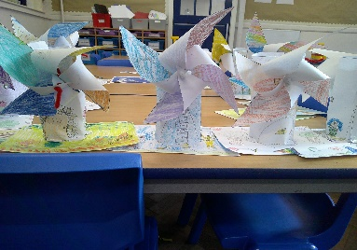

This term we will:
- Ask the eco champions to make recycling posters (Tilly Mae, Grace and Stanley)
- Research giant games for the playground (Leo, Anna)
- Write to Mrs Adlam about ordering the games (Abeedah, James, Beatrix)
- Watering the plants (April, Zoya, William, Logan, Siya)

