Geography Knowledge Organiser: How does the weather affect our lives? Year 2
Climates
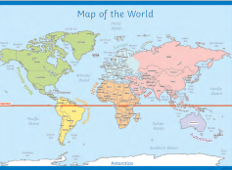

Countries around the world have different climates. Countries near the equator have hotter climates and the Arctic and Antarctic have much colder climates. Climates can affect many things, such as which plants can grow. Many animals are specially adapted to the climate they live in.
Key Vocabulary | Meanings
Drought | When there is no rainfall for a long time.
Extreme | Beyond what is normal.
Equator | An invisible line across the middle of the earth the countries closet to it our incredibly hot.
Flooding | When usually dry land is covered with a large amount of water.
Observations | What you notice when you look carefully at something.
Record | Keep information about something that has happened, e.g. in writing or pictures.
Seasons | The year is divided into four seasons: spring, summer, autumn and winter.
Temperature | A measure of how hot or cold something is.
Thermometer | An instrument used to measure temperature.
Tornado | A storm with powerful twisting winds.
Climate | The usual weather conditions of an area.

Our Weather
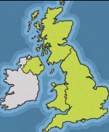 | The weather in the United Kingdom can change from day to day. There are also changes in the weather in each season.  In spring, it is often rainy and the temperature begins to get warmer. In summer, the sun is much stronger. The temperature is warmer than in any other season. In the autumn, the weather turns chillier, windier and there is often rain. In the winter, it is often cold and frosty.
Extreme Weather
In some places around the world, the weather can be extreme and this can be dangerous. People need to take special care in extreme weather such as: droughts, flooding, blizzards, heatwaves and hurricanes. Extreme weather can affect our surroundings as well as us.
