Key Vocabulary | Meanings
landmark | A significant place
artefact | An object from the past
past | Gone by in time and no longer exists.
present | Existing and happening now.
timeline | Order of events
factory | A place where things are manufactured (made).
straw plait | A string or strand made out of pieces of straw woven together.
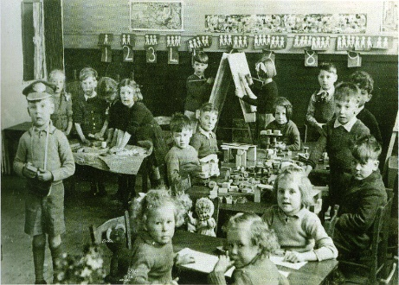
History Knowledge Organiser: Local History Year 2
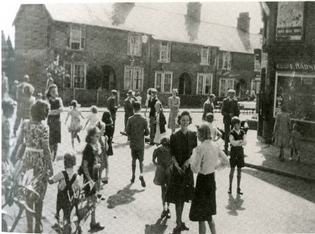

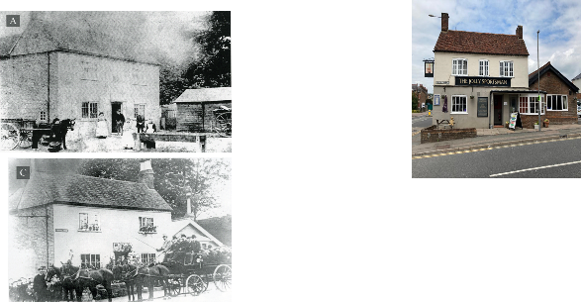
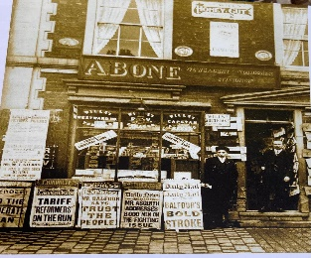
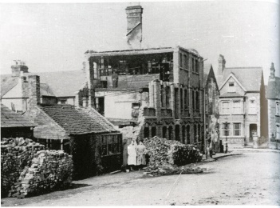

Key facts:
- Chesham is famous for boots, brushes, beer and Baptists.
- There were factories and workhouses in Chesham that made boots, lace, teddy bears and toys, beer, bricks, brushes (wooden) and straw plaits for the hat factories in Bedfordshire
- Chesham has a variety of buildings of different ages and that have had different uses over the years.
- Sir Arthur Lasenby Liberty who founded Liberty London was from Chesham.
- Chesham Station opening is a historically significant event for Chesham.

